**JA Group Project: RSI Meme Generator**

**Team:** Jully, Mauricio and Reyna

**Frontend:**

* Define 1 persona for our site
* Define 1 user story for our persona
* Document 1 use case/interaction flow based on our persona
  + List the specific steps the user must take to arrive at their goal. Include the system responses for each user-initiated action
* Wireframes

**Backend:**

* Break the data presented into entities
* Break the entities into attributes
* Identify all keys: primary keys and foreign keys (AKA relations)

**Summary:**

**Goals:**

**Features:**

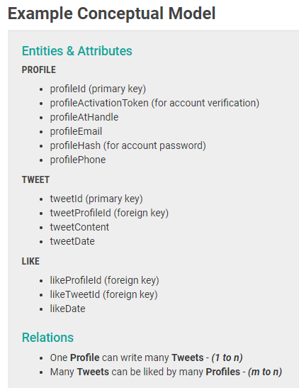

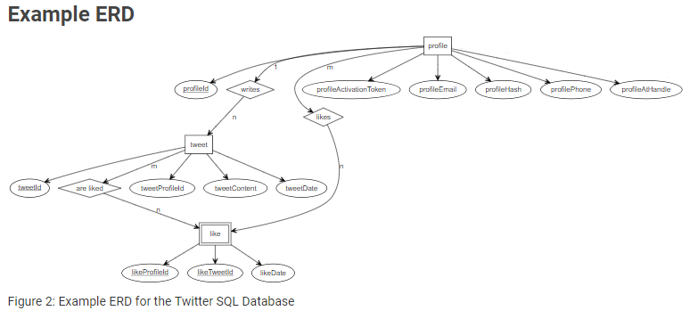

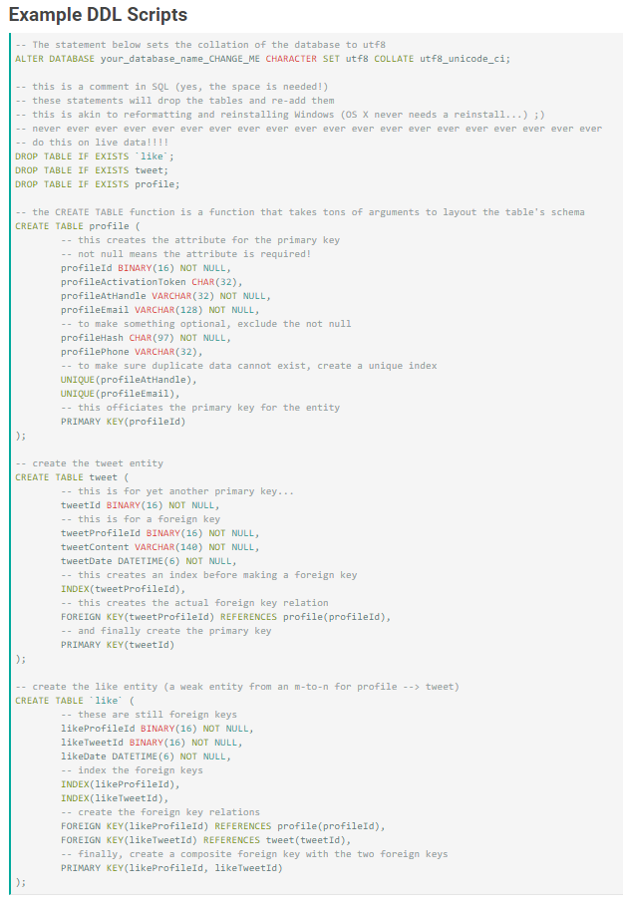

**Persona**

**Name:** Mia Petersen

**Profession:** HR Manager at RSI ABQ

**Personality:** Friendly af

**Technology:** apple user, loves google features and Microsoft Office. Still feel uncomfortable with Slack

**Proficiency:** doesn’t do social media and figure stuff out easily

**Likes/Dislikes:** thinks that technology makes things easier to connect with people and exchange information/thinks internet can waste time and interfere in productivity

**Attitudes/Needs:** Likes being productive and need an easy way to communicate with colleagues

Why choose this site over other options: easy usage and funny content

Usage Preconditions: wants to personalize her on meme

Usage Post conditions: shared her meme with colleagues

Frequency of use: daily

Interaction Flow:

1. Navigates to RSI ABQ Memes via her desktop
2. Chooses an image to personalize
3. Types a small text on the image
4. Saves her image
5. Shares her image with colleagues